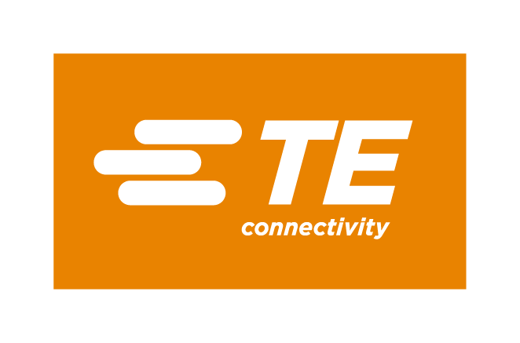

Confidentiality and Compliance Agreement

In partial consideration of my participation in TE AI CUP project hosted by TE Connectivity (individually and collectively, “TE”) and, as part of the performance of the duties of such participation, including my access to confidential information of TE, I agree as follows:

- TE Confidential Information. “TE Confidential Information” is information developed, created, or discovered by TE that has value to TE’s business and is not known to TE’s competitors or by the general public, or is otherwise proprietary or confidential to TE. TE Confidential Information may include, but is not limited to, data, know-how, manufacturing methods, formulas, algorithms, computer programs, processes, designs, sketches, photographs, plans, drawings, product concepts, improvements, specifications, samples, reports, laboratory notebooks, vendor names, customer and prospective customer names, distributor names, cost and pricing information, market definitions, business plans, marketing plans, financial plans, customer and prospective customer development information and strategies, business opportunities, sales methods, inventions, trade secrets, ideas, research and development activities and plans, and employee and/or personnel information, including compensation, skill, and areas of expertise. For the avoidance of doubt, I acknowledge that TE Confidential Information includes all non-public information of value to TE’s business that I may have in any way acquired or learned as a result of my participation in TE AI CUP project.

- Obligation of Confidentiality. I agree, both during and after my participation in TE AI CUP project to keep TE Confidential Information secret. I agree not to disclose, record, or in any way make use of TE Confidential Information for so long as such information remains non-public. I also agree not to remove or otherwise transmit TE Confidential Information from TE’s premises or possession without the consent of an authorized TE representative. Further, I agree to keep secret any third party information, including but not limited to, information received by TE from customers, prospective customers, and suppliers, that is covered by a confidentiality agreement between TE and the third party (“Third Party Confidential Information”), to which I am given access during TE AI CUP project, and agree to adhere to the terms of the agreement between TE and the third party.

- TE Property. All TE Confidential Information, as well as all patents, patent rights, copyrights, copyrightable works, trade secret rights, trademark rights, and other rights (including, without limitation, intellectual property rights) anywhere in the world related to TE Confidential Information, is, and shall be, the sole and exclusive property of TE. I hereby assign to TE any and all rights, title, and interest I may have or acquire in such TE Confidential Information and related rights. I agree to deliver all TE Confidential Information and Third Party Confidential Information, including all copies or computer records thereof, along with any other TE property, to TE on or before my last day of collaboration with TE concerning this project. I further agree not to make any written record of, nor to make any use of, such TE Confidential Information and Third Party Confidential Information thereafter.

- TE Intellectual Property (“IP”)。

- I agree to work with and/or assist my team to report biweekly by mail to TE the Work Results and IP I conceived or developed during my participation in TE AI CUP.

- Unless otherwise provided in another agreement, all IP rights related to the Work Results and IP, including but not limited to the Work Results and IP developed or created by me alone through using the Development Kit (software and hardware) provided by TE, or by me in collaboration with TE shall belong to TE.

- No Contract of Employment. I agree that this Agreement is not a contract of employment, and no rights to employment, continued employment, advancement, or reassignment are hereby created.

- Governing Law. This Agreement shall be governed by and construed under the laws of the jurisdiction of my primary work location.

- Compliance to Anti-Bribery Law. I hereby promise that my performance of any obligation under this Agreement will not violate any anti-bribery or anti-corruption law of any jurisdiction including the United States of America’s Foreign Corrupt Practices Act and any country which is or will become a signatory to the OECD Convention on Combating Bribery of Foreign Public Officials.

Participator: Bec David Arredondo Lugo
Participator’s University：CETYS Universidad
Signature：
Date: 27 de Octubre de 2021

